◯◯Standard | Items:
1.OA.01 -  Solve addition and subtraction word problems within 20 involving situations of adding to, taking from, putting together, taking apart, and comparing with unknowns in all positions, e.g., by using objects, drawings, and equations with a symbol for the unknown number to represent the problem. | 3.0  - Max had 15 cookies. Kate took away 4 of his cookies. How many cookies does Max have left? Show how you solved the problem.  - There were 9 birds in a tree. 7 more birds flew to the tree. How many birds are in the tree now? Show how you solved the problem.  - Sam has 8 bones. He has 16 dogs to feed. If each dog gets one bone, how many more bones does Sam need? Show how you solved the problem.
2.0
- There were 17 cats in a field. 8 of the cats went home. 9 cats are left in the field. Draw a picture to show how this problem was solved. 17-8=9
- Bill had 12 fish in a bowl. Dan brings over 6 more fish. There are 18 fish in the bowl now. Write an equation for this story. _____ _____ _____ (include picture)

1.OA.06 -  Add and subtract within 20, demonstrating fluency for addition and subtraction within 10. Use strategies such as counting on; making ten (e.g., 8+6=8+2+4=10+4+14); decomposing a number leading to a ten (e.g., 13-4=13-3-1=10-1=9); using the relationship between addition and subtraction (e.g., knowing that 8+4=12, one knows 12-8=4); and creating equivalent but easier or known sums (e.g., adding 6+7 by creating the known equivalent 6+6+1=12+1=13) | 3.0 Choose a strategy from the box.  Counting on, Using a Number Line, Making a Ten, Using Related Facts, Using Doubles, Using Double Plus 1, Using Doubles Minus 1  Solve and show your strategy.  - 11+3=  - 10+5=  - 15-5=  - 19-2=
2.0 Solve.
- 2+4=
- 7+3=
- 6-5=
- 3-0=
- Fill in the blank spaces 4, ___, ____,___
4+3=_________

6. 5+2+5=______ (Make a ten strategy, need to draw in the
slanted lines and box.)
7. Circle the related addition fact. 5-2=3
- 4+1=5
- 3+2=5
- 5+0=5

1.NBT.01 -  *Count to 120, starting at any number less than 120. In this range, read and write numerals and represent a number of objects with a written numeral. | 3.0  - Fill in the missing numbers:  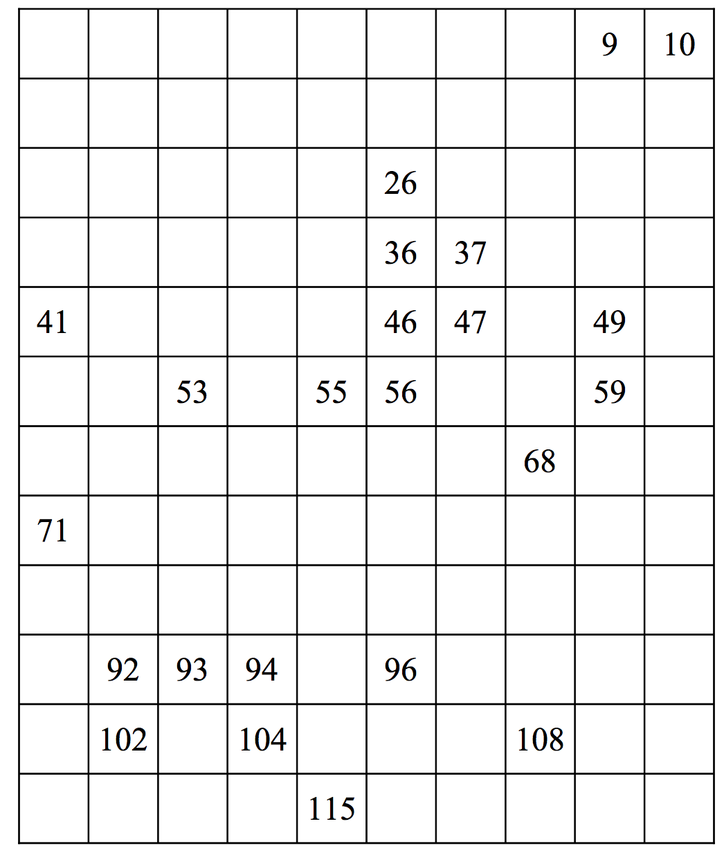  - Count and write the number:  * * * * * * * * * *  * * * * * * * * * *  * * * * * * * * * *  * * * *  Answer:
2.0
- Write in the missing numbers:
46, 47, ____, ______, ______, 51, 52

1 | 2 |  | 4 | 5 | 6 | 7 | 8 | 9 | 10
11 | 12 | 13 |  | 15 | 16 | 17 |  | 19 | 20
21 |  | 23 | 24 | 25 | 26 | 27 | 28 | 29

3.
50 | 51 | 52 |  | 54 | 55 |  |  | 58 | 59
 | 61 | 62 | 63 |  | 65 | 66 | 67 | 68
70 | 71 |  | 73 | 74 |  | 76 | 77 |  | 79

